**EXERCISES DATABINDING**

EXERCISE 1

Make a WPF application in which a collection of student objects is created and displayed.

De list of students is connected to the GUI using databinding.

The field state is a list of states.

The GUI needs to be created as follows:

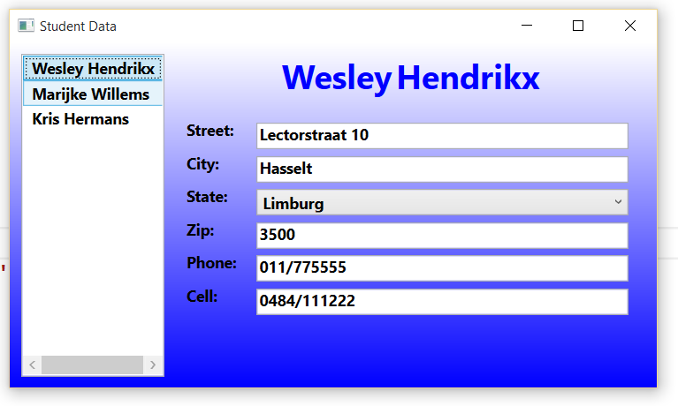

EXERCISE 2

Together with this exercise you will find a rar file with the pictures of some presidents of the US. Make a WPF application which shows these presidents in a listbox. When a president is selected his name is displayed in the title.

Start screen:

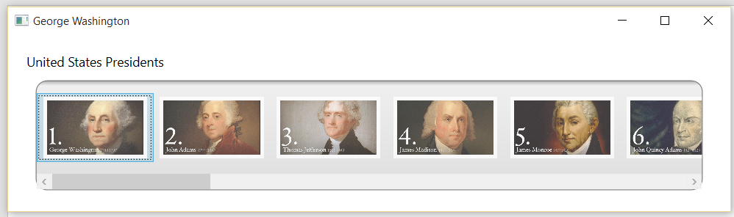

When a president is selected:

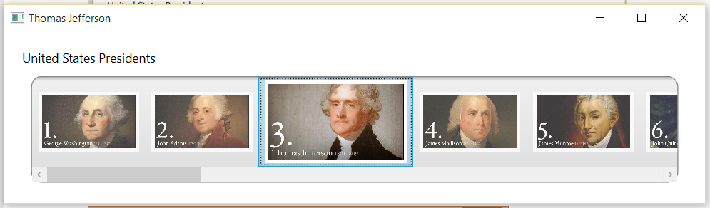

The list of the presidents:

* Pictures\gw1.jpg Name="George Washington
* Pictures\ja2.jpg Name="John Adams"
* Pictures\tj3.jpg Name="Thomas Jefferson"
* Pictures\jm4.jpg Name="James Madison"
* Pictures\jm5.jpg" Name="James Monroe"
* Pictures\ja6.jpg" Name="John Quincy Adams"
* Pictures\aj7.jpg" Name="Andrew Jackson"
* Pictures\mv8.jpg" Name="Martin Van Buren"
* Pictures\wh9.jpg" Name="William H. Harrison"
* Pictures\jt10.jpg" Name="John Tyler"
* Pictures\jp11.jpg" Name="James K. Polk"
* Pictures\zt12.jpg" Name="Zachary Taylor"
* Pictures\mf13.jpg" Name="Millard Fillmore"
* Pictures\fp14.jpg" Name="Franklin Pierce"
* Pictures\jp15.jpg" Name="James Buchanan"
* Pictures\al16.jpg" Name="Abraham Lincoln"
* Pictures\aj17.jpg" Name="Andrew Johnson"
* Pictures\ug18.jpg" Name="Ulysses S. Grant"
* Pictures\rb19.jpg" Name="Rutherford B. Hayes"
* Pictures\jg20.jpg" Name="James Garfield"

Tips:

* You’ll need to change the template of the ListBox.
  + Maybe there should be a ScrollViewer control in that template?
  + Use the “IsItemsHost” on a control that derives from the Panel class (e.g. StackPanel) to indicate that the panel is to be used as a container for the items that will be displayed.
* You’ll need to set the ItemTemplate of a ListBoxItem.
* Use the Image control to show a president

Extra:

Add an effect that enlarges the images if you hover over them.

Oefening 3

Make a WPF applicatie in which the screenshot below shows the start situation. The second screenshot is the situation after the input of first and last name. The fullname is built together every time one of the textboxes loses the focus.

The close button stops the application.

